 

ITI- CMS Final project

Project Documentation

Prepared by:

ITI- CMS Final project- Team #4

1-Ayman Mohamed Mostafa (Team Leader)

2-Mansour Ahmed Mansour

3-Somaya Mahmod Hassan

Project Supervisor

Eng. Noha Salah

ITP_CMS_Alex_Q3

20/5/2021

# Introduction

The aim of this project is to create a responsive and professional wordpress website for Jumia Company and the site of the company is: <https://group.jumia.com/>.

The work started by defining the requirements of the website. We decided to use WordPress publishing platform. For that reason, the team was already familiar with the publishing platform, and we knew how to use it. The next step was designing a website layout, which should be user-friendly and easy to use by every mobile device and desktop. After creating a clear design, it was easy to code the front-end of the website layout.

The organization for which the work was done is a leading e-commerce platform in Africa called Jumia. Jumia is built around a marketplace, Jumia Logistics, and JumiaPay. The marketplace helps millions of consumers and sellers to connect and transact. Jumia Logistics enables the delivery of millions of packages through our network of local partners. JumiaPay facilitates the payments of online transactions for Jumia's ecosystem. With over 1 billion people and 500 million internet users in Africa, Jumia believes that e-commerce is making people's lives easier by helping them shop and pay for millions of products at the best prices wherever they live. E-commerce is also creating new opportunities for SMEs to grow, and job opportunities for a new generation to thrive. Also, it has over 5,000 employees in more than 10 countries in Africa, Jumia is led by top talented leaders offering a great mix of local and international talents and is backed by very high-profile shareholders. Jumia is committed to creating sustainable impact in Africa. Jumia offers unique opportunities in a vibrant and booming environment, creating new jobs, new skills, and empowering a new generation.

# Plan

Planning is the first and the most important thing to do before starting to build a website. “Building a website without a plan is like constructing a building without blueprints”. Without a plan, the website will be a maze to a customer, things are in the wrong places, and there are too many features. The plan identifies the purpose of the website, assigns team roles, and identifies the structure of the website. After it has been decided what pages the website will contain the mock-up of the website could be sketched. The next step is designing the website and the last but not the least step is testing the website and ensuring that the appearance of the website is in a necessary way in all browsers.

The project was started by defining the requirements of the website. The next step was planning and creating a sitemap for the website. After creating a sitemap, it was time to sketch some mock-ups and with the mock-ups create the website design.

# Requirements

## Requirements document

The requirements document contains all functional and non-functional requirements of the website. The document should be written in the future tense because it is established before development. Before starting any coding, it is important to determine requirements because then there is a guide to follow, ensuring that the website meets its specifications.

The requirements document was created in the meeting. In that meeting, we decided that the website will be built on WordPress, and the website needs a new domain name and a new web hosting server. Also, features of the website should be at the same as the jumia group website, and it has to work flawlessly on mobile devices and desktops. After the meeting, we created the requirements document.

## Functional requirements

Functional requirements specify what website should do. In our case a functional requirement could be:

* The website shall be able to let the user knew news about jumia group.

## Non-functional requirements

Non-functional requirements describe system attributes like reliability and usability. In our case a non-functional requirement could be:

* The website shall be easy to use with every mobile device and desktop.

# Wordpress

## Content Management System (CMS)

The **Content Management System (CMS)** is a software which stores all the data such as text, photos, music, documents, etc. and is made available on your website. It helps in editing, publishing and modifying the content of the website.

## Wordpress Overview

WordPress is an open source **Content Management System (CMS)**, which allows the users to build dynamic websites and blogs. Wordpress is the most popular blogging system on the web and allows updating, customizing and managing the website from its back-end CMS and components.

WordPress was initially released on 27th May, 2003 by Matt Mullenweg and Mike Little. WordPress was announced as open source in October 2009.

WordPress is a free and priceless web software you can use to create a website, a blog or an application. You can transform your website into almost anything that you can imagine, thanks to thousands of plugins and themes available. “The core software is built by hundreds of community volunteers”. WordPress is used by over 64 million websites and therefore, it is the most popular blogging system in use on the web.

WordPress' market share is 40% of all websites.661 new wordpress sites go live each and every day.

The WordPress Dashboard is a first screen which will be seen when you log into the administration area of your blog which will display the overview of the website. It is a collection of gadgets that provide information and provide an overview of what's happening with your blog. You can customize your needs by using some quick links such as writing quick draft, replying to latest comment, etc.

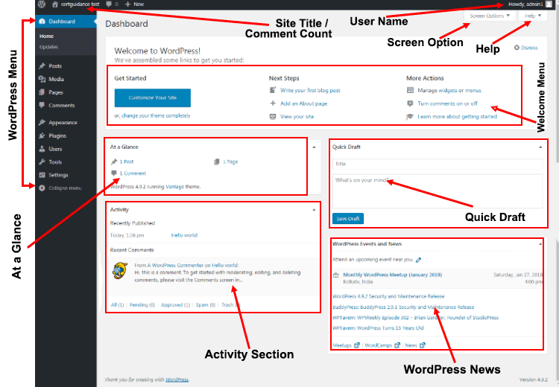

Figure ‎4.1: wordpress dashboard

## Wordpress Advantages

* It is an open source platform and available for free.
* CSS files can be modified according to the design as per users need.
* There are many plugins and templates available for free. Users can customize the various plugins as per their need.
* It is very easy to edit the content as it uses WYSIWYG editor (What You See Is What You Get) is a user interface that allows the user to directly manipulate the layout of document without having a layout command).
* Media files can be uploaded easily and quickly.
* It offers several SEO tools which makes on-site SEO simple.
* Customization is easy according to the user's needs.
* It allows creating different roles for users for website such as admin, author, editor and contributor.
* Multilingual: It allows translating the entire content into the language preferred by the user.

## Wordpress Disadvantages

* Using several plugins can make the website heavy to load and run.
* PHP knowledge is required to make modifications or changes in the WordPress website.
* Sometimes software needs to be updated to keep the WordPress up-to-date with the current browsers and mobile devices. Updating WordPress version leads to loss of data, so it a backup copy of the website is required.
* Modifying and formatting the graphic images and tables is difficult.

## Web hosting

Web hosting is a service that allows companies and private persons maintain and share their websites via the World Wide Web. Web hosting usually contains email accounts with their own domain part which is generally the same as a wanted domain name.

The Internet is overflowing all kinds of web hosting providers. The biggest difference between providers is price and features. Usually, when the provider price is higher, the features are better than those of the low-cost provider. Sometimes the price of one service of one provider may be much higher than that of another whereas the features are much worse. That is exactly how the former web hosting provider of Wildcard UK Limited was, free with poor features. After checking up all kinds of web hosting providers, we ended up choosing a provider called Wildcard UK Limited. Wildcard UK Limited suited up perfectly to our purpose with a free price and encompassing features.

Wildcard UK Limited is a leading hosting and interconnectivity provider based in Newcastle upon Tyne, Wildcard Networks has been growing rapidly. Our local Newcastle datacenter facility allows us to provide flexible, high-speed but cost-effective solutions to local businesses, and our 10Gb/s national optical network allows reach to locations further afield and into Europe.

## Domain name

A domain name known as a web address, is a service which allows web addresses of companies and brands to be in a recognizable form. Web addresses would be too hard to remember without a domain name servers, like e.g. 194.485.249.1. With a domain name, you can use a personal name or word on your website and email addresses.

We needed a domain name for the website. It was easy to get a new domain name while getting a new web hosting service. Luckily, a wished and much more recognizable domain name, http://iti-project.infinityfreeapp.com, was available.

# Design

We created a sitemap for each page of the wordpress website as a design and structure of the website to have a guide to follow, ensuring that the website meets its specifications, and features of the website have the same as the jumia group website.

## Sitemap

A sitemap is a planning tool which helps to organize and clarify a website structure. It helps you decide which pages need to be on your website and to exclude unwanted pages. A sitemap is usually a flowchart or a draft of the content that your website needs and it should be a starting point for your new website design.

A Slickplan sitemap design tool was used to create a flowchart sitemap for the website. It contains all main pages and subpages and sections and content of each section of the website. Slickplan is a web app, which allows you to plan any website project. You can plan everything from your website’s sitemap structure to a user flow.

The link of my account slickplan in which I made all sitemaps: https://iticms.slickplan.com/dashboard

The following figures illustrates the sitemap for each page and sections and contents of each section:

### Sitemap for Home page

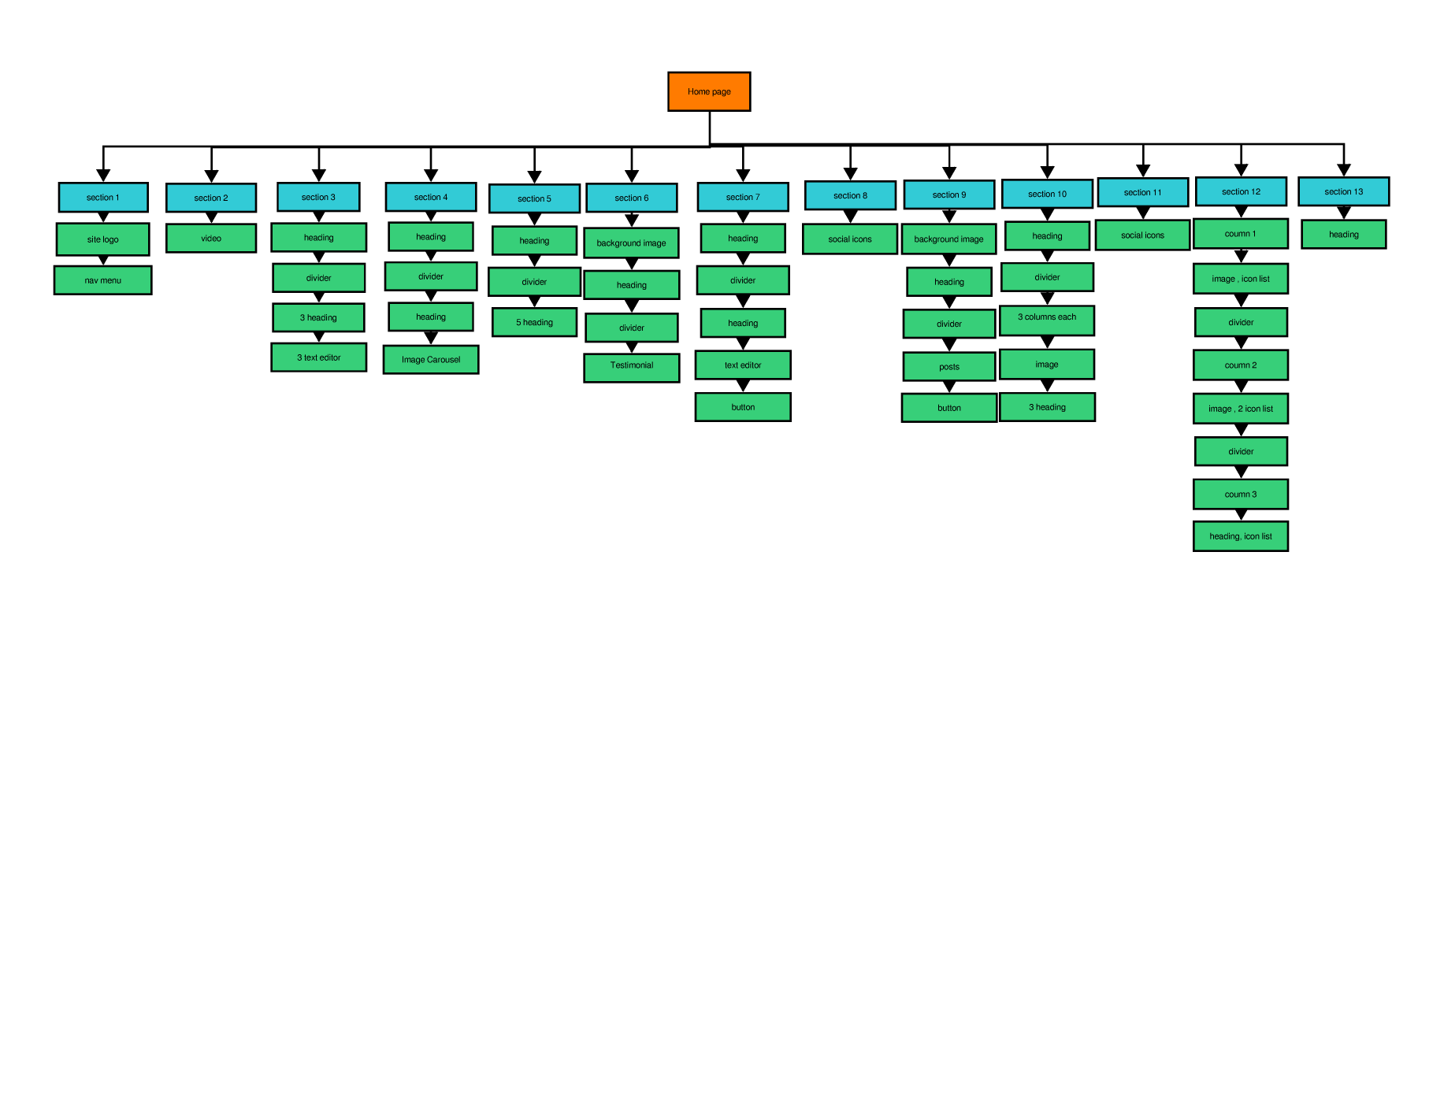

Figure ‎5.1: sitemap of home page

### Sitemap for investor relations page

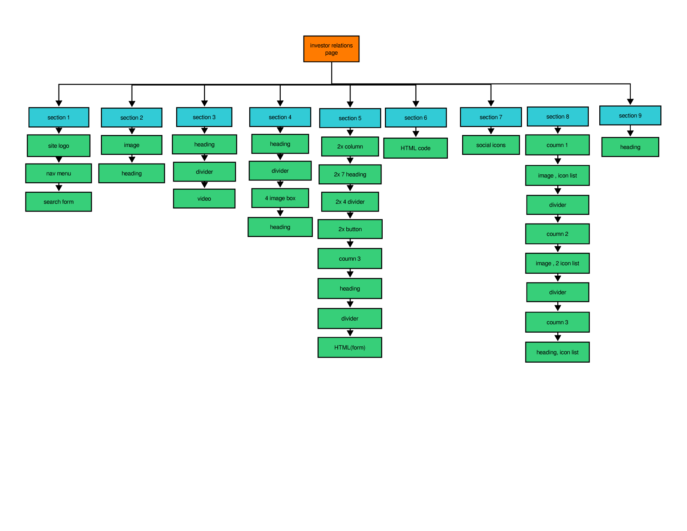

Figure ‎5.2: sitemap of investor relations page

### Sitemap for press kit page

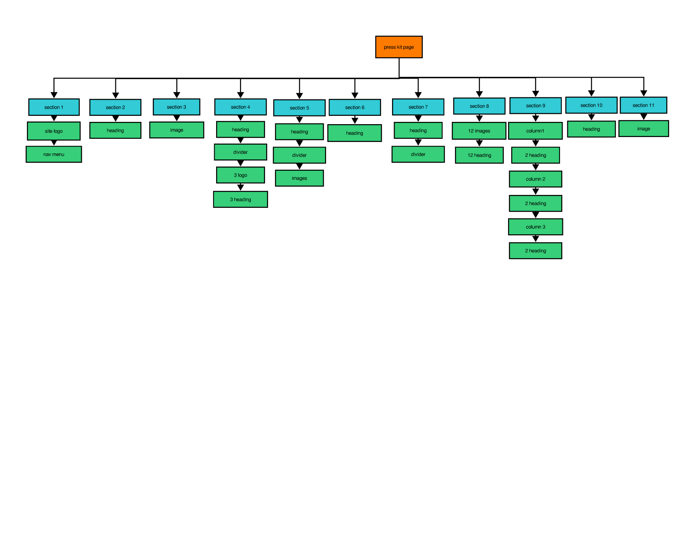

Figure ‎5.3: sitemap of press kit page

### Sitemap for blog page

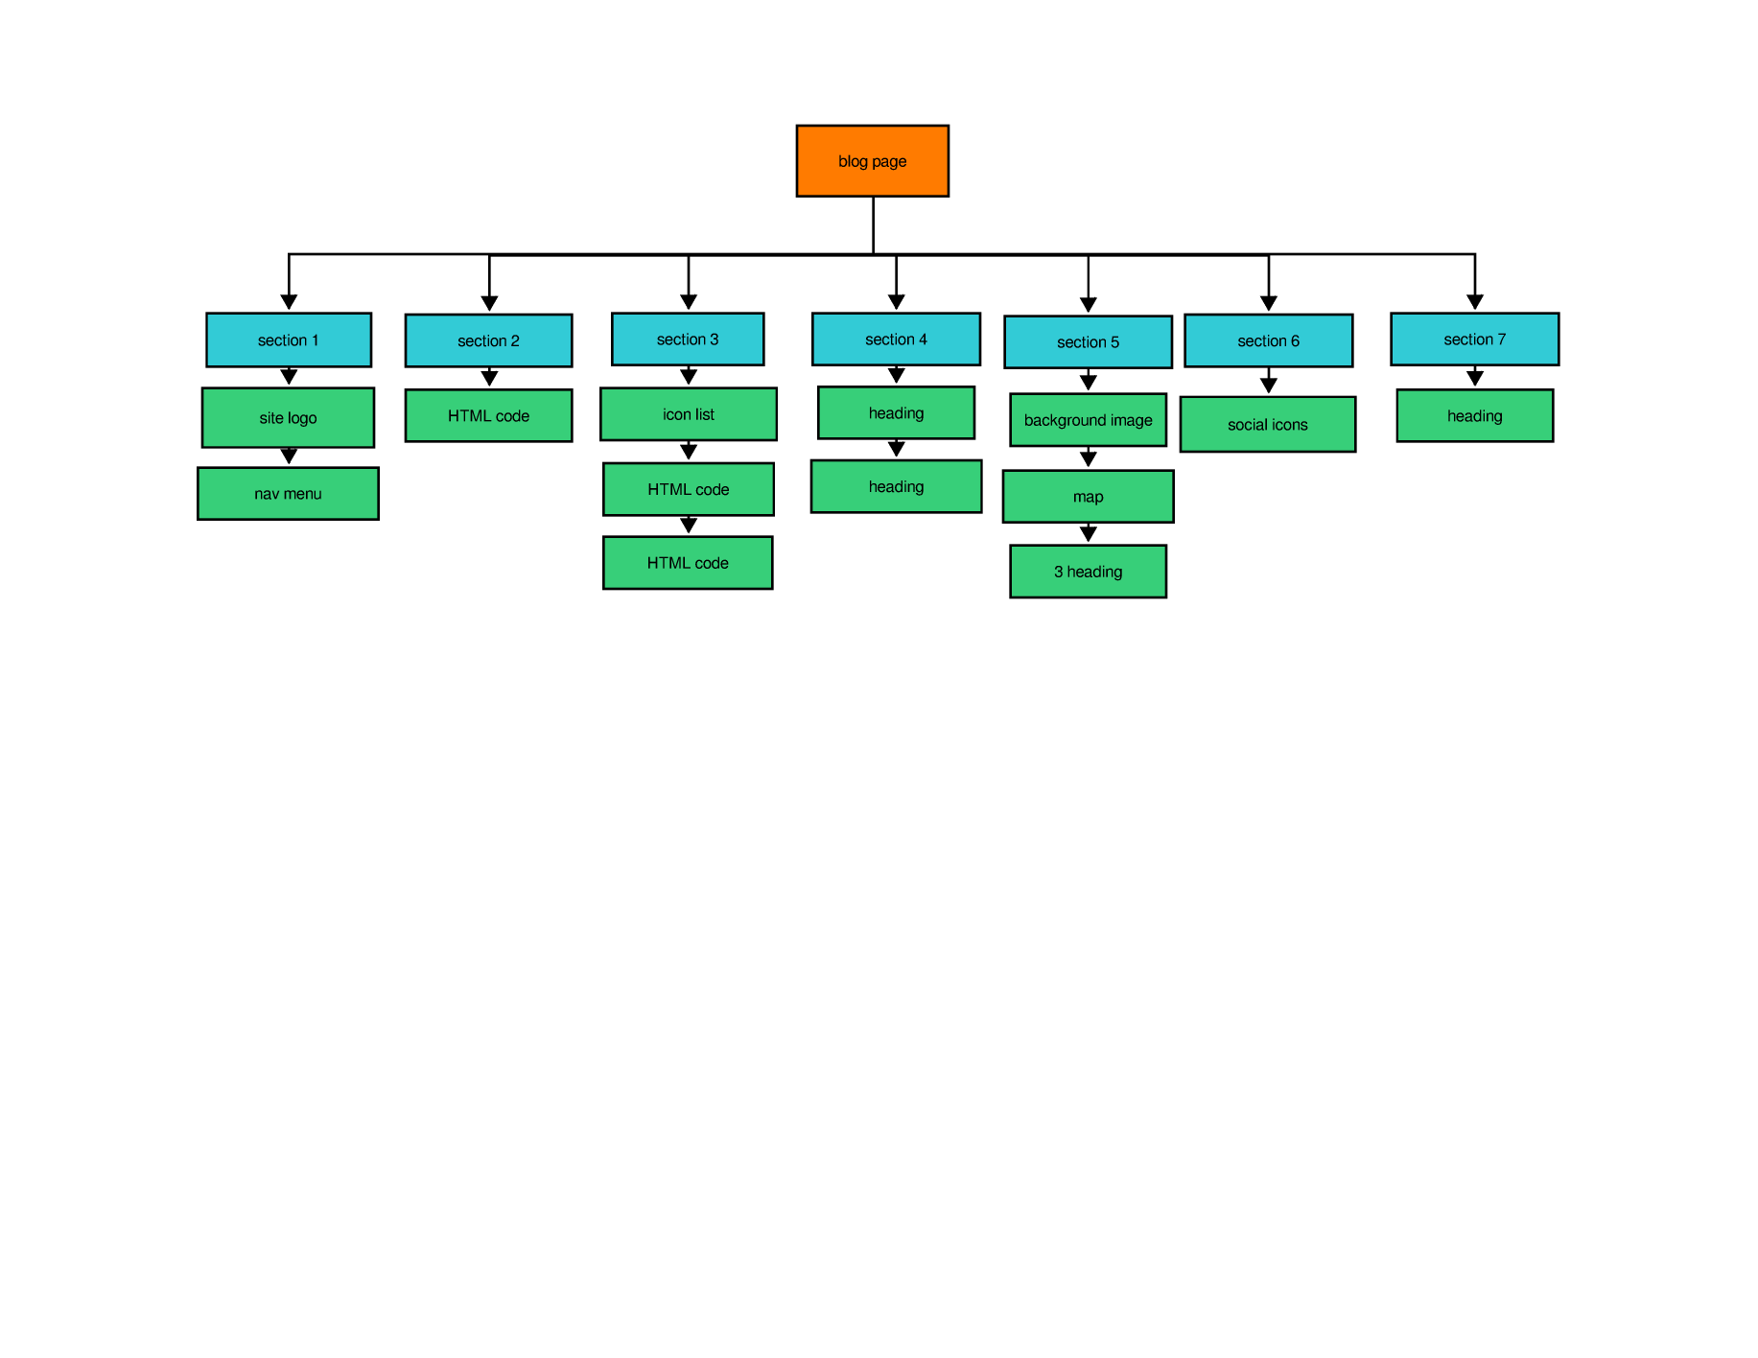

Figure ‎5.4: sitemap of blog page

### Sitemap for contacts page

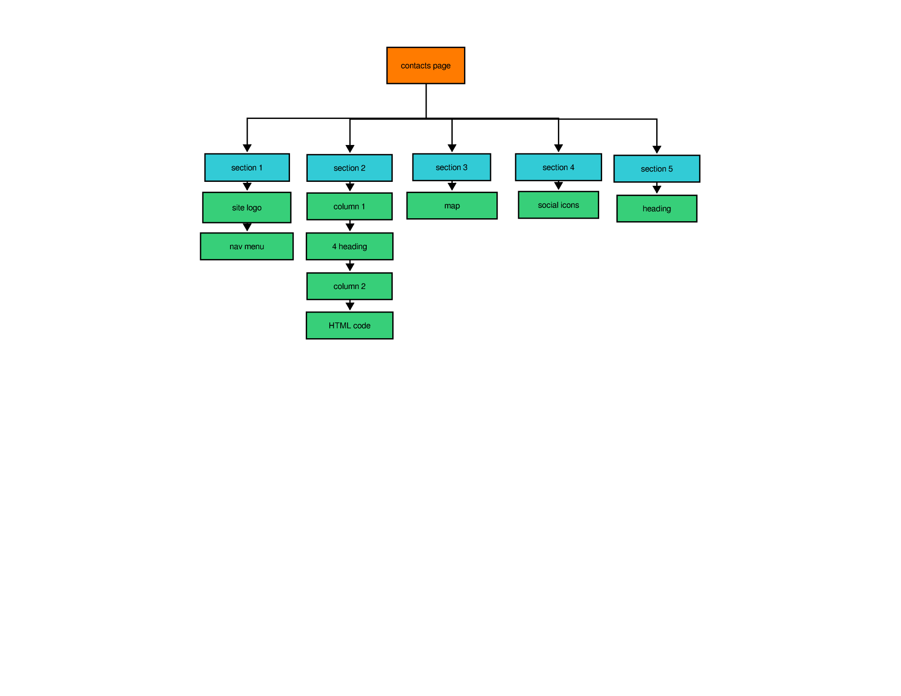

Figure ‎5.5: sitemap of contacts page

### Sitemap for covid page

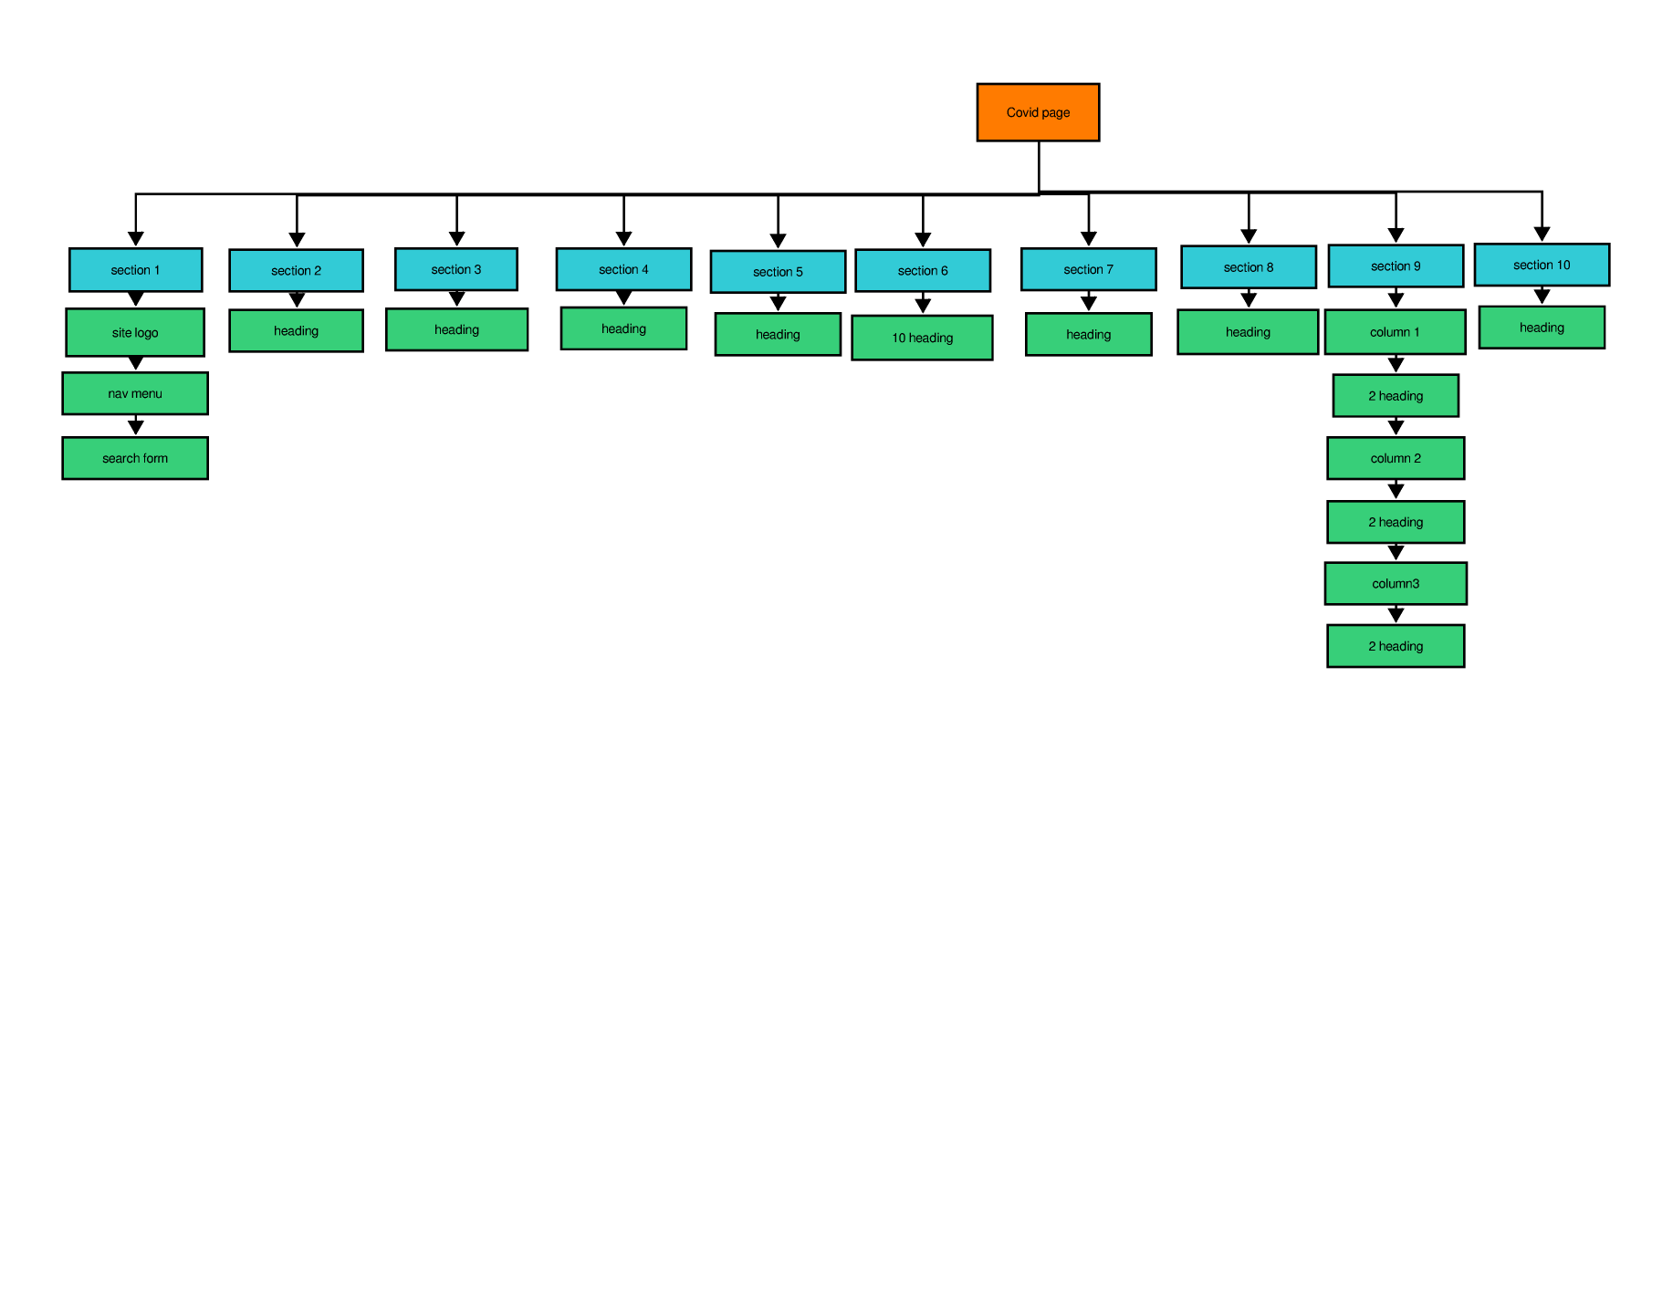

Figure ‎5.6: sitemap of covid page

# Implementation

## Setting up wordpress

Installing WordPress is quite easy because nowadays web hosting servers have a quick installation for web applications.

Create an account on InfinityFree website which provide a free hosting to make the wordpress website live, Then I choose a domain name for the website is: <http://iti-project.infinityfreeapp.com>.

1. **Login to your control panel** by finding your account in the client area and click Login to Control Panel.
2. **Go to Softaculous Apps Installer** inside your control panel.
3. **Find wordpress in Softaculous** through the search menu, featured scripts or category dropdowns.
4. **Click "Install Now"**
5. **Fill in the required settings.** You probably want to clear the "Directory" field if you want the script to be your main site and change the admin username, password and e-mail address and create a new database on your web server for WordPress before you can start the installation.
6. **Click Install** and wait for the installation to be completed.
7. **Login to the admin area of your script** to start customizing your website!

At the beginning of the installation, you need to run the WordPress installation script by accessing the URL via a web browser. The URL you want to access is your WordPress directory name. If you moved all the files in the root directory, you could access the installation page by http://example.com. If you moved the whole folder called “mywebsite” to your web server, you could access the setup page by http://example.com/mywebsite. As all WordPress were moved files to a root directory of the web server, the configuration file was accessed by <http://iti-project.infinityfreeapp.com>.

The first thing you have to do when running the installation script is choosing the language (figure 6.1).

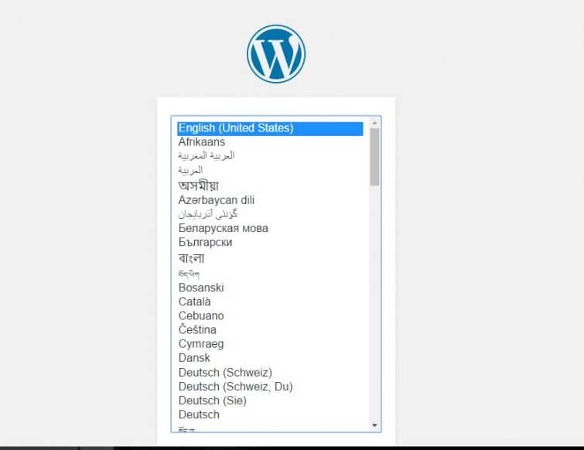

Figure ‎6.1: wordpress language

The next thing you have to do when running the installation script is filling the database form (figure 6.2). In the form, you need to enter the name of the created database, your MySQL username, and your MySQL password. Database Host and Table Prefix fields can be left unchanged.

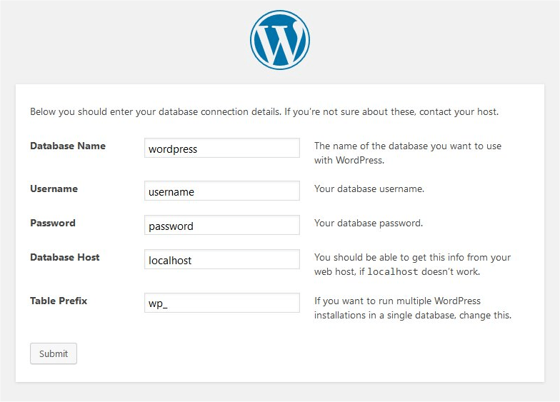

Figure ‎6.2: install database for wordpress

In the next form (figure 6.3) the title of the website, a decide admin username and password and your e-mail address are given. Also, you need to decide if you allow search engines to find your website.

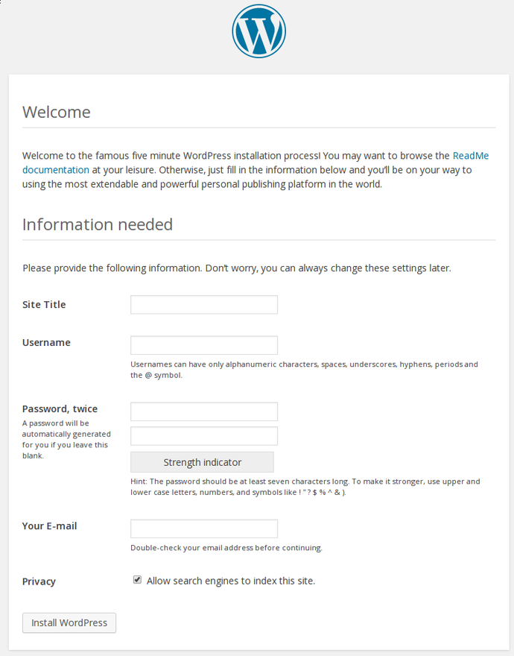

Figure ‎6.3: wordpress website information

When everything has been done properly, WordPress lets log into the website with your chosen username and password (figure 6.4).

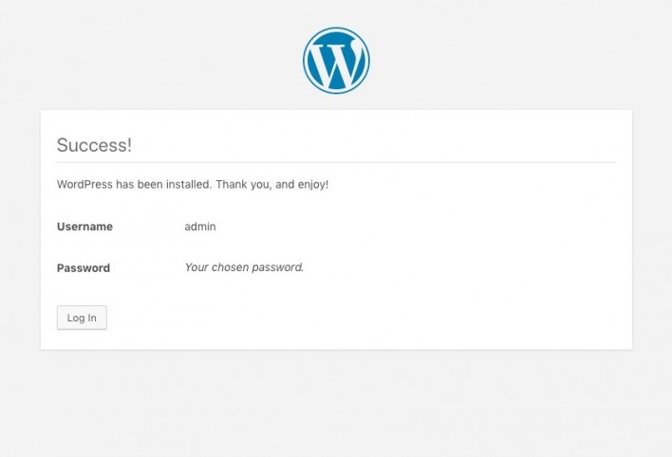

Figure ‎6.4: wordpress website login

After a successful installation of WordPress, it was time to implement the created design on the website. At first, it was needed a WordPress theme. Thankfully, thousands of themes are available on the worpress.org website. The most basic Bootstrap theme on available was downloaded because the style of the template needed to be customized radically.

We used the Hello Elementor theme which is the theme of Elementor page builder, because we decided to build the website from scratch by Elementor pro page builder.

## Install theme & plugins

1. Choose Hello Elementor theme (we will build a website from scratch by Elementor pro page builder).
2. Install and activate plugins: Elementor, Elementor Pro, WP File Manager, and WPForms Lite.

Contents

1. Introduction 2

2. Plan 3

3. Requirements 4

3.1. Requirements document 4

3.2. Functional requirements 4

3.3. Non-functional requirements 4

4. Wordpress 5

4.1. Content Management System (CMS) 5

4.2. Wordpress Overview 5

4.3. Wordpress Advantages 6

4.4. Wordpress Disadvantages 7

4.5. Web hosting 7

4.6. Domain name 7

5. Design 9

5.1. Sitemap 9

5.1.1. Sitemap for Home page 10

5.1.2. Sitemap for investor relations page 10

5.1.3. Sitemap for press kit page 11

5.1.4. Sitemap for blog page 11

5.1.5. Sitemap for contacts page 12

5.1.6. Sitemap for covid page 12

6. Implementation 13

6.1. Setting up wordpress 13

6.2. Install theme & plugins 18

Table of figures

Figure ‎4.1: wordpress dashboard 6

Figure ‎5.1: sitemap of home page 10

Figure ‎5.2: sitemap of investor relations page 10

Figure ‎5.3: sitemap of press kit page 11

Figure ‎5.4: sitemap of blog page 11

Figure ‎5.5: sitemap of contacts page 12

Figure ‎5.6: sitemap of covid page 12

Figure ‎6.1: wordpress language 14

Figure ‎6.2: install database for wordpress 15

Figure ‎6.3: wordpress website information 16

Figure ‎6.4: wordpress website login 17